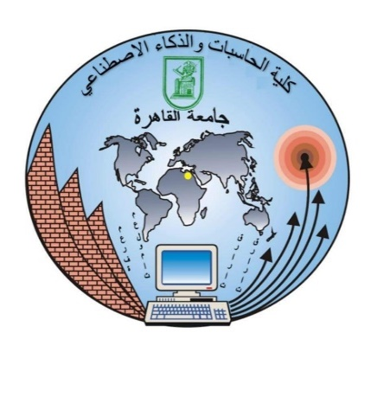

**Li-Fi**

**The project submitted of IT department**

**by**

Abdelrahman Essam Mohamed - Abdelrahman Kamal Helal

Yasmin Ashraf - Mohamed Saad Elden

Youssef Sabry Azuz

**Supervisor**

Prof. Iman Sanad

TA. Mahmoud Sami

**2018-2022**

**Abstract**

At this point of time, you must be sitting in a room illuminated by light. When a person hears the word 'Light' the first thing that comes to an individual's mind is some luminous and bright object but believe me when I say that its soon going to change. The next time you think about 'Light' you will think about the chores it does for you. What I am talking about is Light-Fidelity abbreviated as Li-Fi.  
For those who have heard about it before this blog will be helpful in knowing how it will affect our daily lives and for those who haven't, I know it sounds similar to Wi-Fi but there is one huge difference between the two which makes Li-Fi more reliable and faster.

Li-Fi is a technology introduced by Harold Hass from the University of Edinburgh. Li-Fi uses LED's (Light Emitting Diodes) which emit light waves invisible to a naked human eye. These light waves are received by the destination system and hence starts the processing of signals.  
Li-Fi is popularly called the 'internet of things' and let me tell you why it is true. In no less than a decade each and every appliance of your home will become Li-Fi operated. For instance, your refrigerator will notify you of any shortage, your home will manage the power consumption itself and many more things to come. This will surely save a lot of your time and energy.

The most important thing is how it is different from the current tech Wi-Fi. Actually, Li-Fi uses light waves but Wi-Fi uses radio waves, this makes Li-Fi far **faster** than Wi-Fi. Li-Fi can elevate the speeds up to 10Gbps which means you can download a High-Definition movie within seconds. Li-Fi is also **cheaper technology** than Wi-Fi. Li-Fi is accessible in areas where Wi-Fi can't operate for instance in airplanes. Also, it causes **no health issue regarding the radiations** so it is also safe in hospitals and nuclear plants.  
The biggest disadvantage of Li-Fi is that it **cannot penetrate the walls** and consequently it can only be used in confined areas, also its range till now is up to 10 meters. But what's bane in one case can serve as a boon through another perspective. As Li-Fi doesn't penetrate the walls, it is a more secure connection than Wi-Fi.  
Well, I must say one thing that it has best of both worlds. But experience has taught me one thing and that is not to judge a book by its cover so we have to wait until the official launch of Li-Fi in our daily lives such that we can conclude what is better. But, one thing is for sure that Li-Fi looks good for our future and is totally in queue to revolutionize our world. I hope this blog was helpful to you. I have given you the facts, history, pros and cons but you are the one to make decisions.

**CONTENTS**

**Chapter 1. Li-Fi**

1.1 Introduction

1.2 History

1.3 Implementation

1.4 Li-Fi vs Wi-Fi

1.5 Limitations

1.6 Advantages

**Chapter 2. Use Cases & Benefits of Li-Fi**

3.1 The benefits of Li-Fi

3.2 Li-Fi in Indoor Positioning System

3.3 Li-Fi in Hazardous Environments

3.4 Li-Fi in Vehicle and Transportation

3.5 Li-Fi in Smart Building

3.6 Li-Fi in Hospitals and Healthcare

3.7 Underwater Communication

**Chapter 3. IOT & Li-Fi in IOT**

4.1 What is IOT

4.2 History of IOT

4.3 IOT architecture

4.4 The layers of IOT

4.5 Middleware is

4.6 Li-Fi in IOT

**Chapter 4. Underwater Communication Using Li-Fi**

* 1. Introduction of Underwater communication using Li-Fi

5.2 Powerful of Li-Fi in Underwater communication

5.3 The Problem with underwater communication

5.4 The stakeholders are

**Chapter 5. Hardware Components**

**5.1 Transmitter Part**

5.1.1 9v battery connector

5.1.2 220-ohm resistor

5.1.3 Led

5.1.4 Aux

* 1. **Receiver part**

5.2.1 Solar panel

5.2.2 Jack

5.2.3 Speaker

**Chapter 6. Experiments**

6.1 Transmission audio on air:

6.2 Transmission data on air:

6.3 Transmission underwater:

**Chapter 7. Conclusion**

**Chapter one**

**Li-Fi**

**1.1 Introduction of Li-Fi**

The Li-Fi technology in some use cases, The Li-Fi is a wireless optical networking technology. Specifically, it is a form of visible light communications (VLC) system that makes use of light-emitting diodes (LED) for data transmission.  **Li-Fi**has a special distinction from other VLC systems. Similar to **Wi-Fi**, **Li-Fi**is the only form of VLC that allows the bidirectional transmission of light. However, instead of the radio spectrum, it makes use of the visible light spectrum through LED lightbulbs outfitted with a special chip. We use it to receive and transmit data by light. It faster 100 times than Wi-Fi technology and the Li-Fi is more secure than Wi-Fi. The purpose of Li-Fi technology is to provide a high-speed data communication using visible light spectrum. Now Li-Fi is on-going of research, it has a potential advantage that can make a supplement RF communication and can be used to improve wireless network performance.

It uses common household LED light bulbs to enable data transfer, boasting speeds of up to 224 GB per second. Considering that the fastest Wi-Fi in the 60 GHz frequency band, can achieve a maximum data rate of 7 GB per second, Li-Fi speed is 100 times faster than that! Not only that, but the rate per square meter or area data rate of a Li-Fi network can be 1,000 times higher than the area data rate of a Wi-Fi network.

**1.2 History**

The earliest known work on modern VLC began at Nakagawa Laboratories in Keio University, Japan. Research on the technology focused on transmitting data by visible light through the use of light emitting diodes (LEDs). Japanese researchers proposed the concept of communication through visible light in 2000. Using LED lights as a base station, the researchers simulated an indoor communication system that would utilize overhead lighting as a medium of transmission. The researchers at Nakagawa saw the prospects brought by VLC technology. They placed plenty of effort into their research into the technology and in 2009, were able to create a high-speed communication technology that reached 100 Mbit/s.

**1.3 Implementation**

**The** Li-Fi uses visible light as a medium for the transmission of data. As a type of VLC system, it requires two components: a photodiode and a light source. The photodiode acts as a transceiver that receives light signals and transmits them back. The light source transmits data using emitted light as the medium. In this case, light emitting diodes (LED) serve as the light source. They are outfitted with a chip that serves as the signal processing unit. LED light bulbs are semiconductors. This means current supplied to the bulb can be modulated, which in turn, modulates the light they emit. This process occurs at extremely high speeds that are unperceivable to the human eye. Data is fed into the light bulb and sends the data at extremely high speeds to the photodiode. It converts the data received into a binary data stream perceivable by humans such as video and audio applications. **Transmission of data** over light to send data over light, Li-Fi systems require a strong, robust light source like LED bulbs. LEDs are different from halogen or filament bulbs as they do not need to warm up. As previously stated, they are semiconductors. They start up quickly and emit light according to the current passed through them. Within the light, the intensity of the colours red, green, and blue (RGB) is finely modulated to embed data into the LED light. (Again, this process is undetectable to the naked eye.) This fine modulation of RGB can be better described as a form of code. Once the light is received by a photodiode, the light is demodulated. The information received is either relayed to a cloud server or transcribed by the receiver itself. Content is then displayed according to the code obtained.

**1.4 Li-Fi vs Wi-Fi**

|  |  |  |
| --- | --- | --- |
| **Parameter** | **Li-Fi** | **Wi-Fi** |
| **Spectrum used** | Visible light | RF |
| **Standard** | IEEE 802.15.7 | IEEE 802.11 |
| **Range** | Visible light spectrum has 10000 times broad spectrum in comparison to RF | Less than Visible light spectrum |
| **Security** | Very High | High |
| **Data transfer rate** | Very high (~ 1Gbps) | Low (100Mpbs - 1Gbps) |
| **Power consumption** | Low | High |
| **Cost** | Low | High |
| **Bandwidth** | Unlimited | Limited |

Back in 2016, announcements were made about an extension of standard Wi-Fi called Wi-Fi Hallow. The project claims to double Wi-Fi’s range of connectivity while also using less power. Because of the announcement, many anticipate its applications for greater mobile connectivity and the Internet of Things (IoT). However, with the impressive speeds of Li-Fi, it is poised to make an even bigger impact than Wi-Fi. Here are several advantages Li-Fi can offer over Wi-Fi.

**1.5 Limitations**

Li-Fi won’t work in the dark...! If the light is completely turned off, there is no Li-Fi. But Li-Fi enabled LED lights can be dimmed low enough that a room will appear dark and still transmit data.

Li-Fi won’t work in sunlight...! Li-Fi can fully operate in daylight. Li-Fi detects the fast changes in light intensity and not on the absolute or slowly varying levels cause by natural disruptions in sunlight.

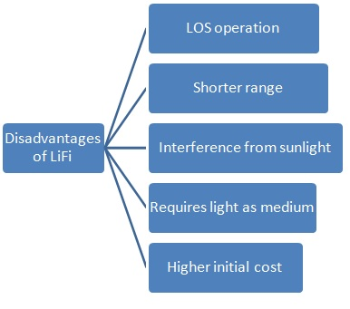

**1.6 Advantages**

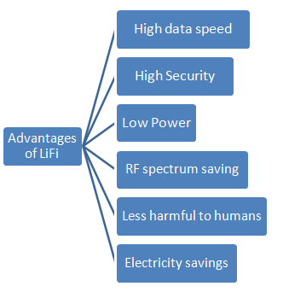

**Speed,** Perhaps the biggest selling point of Li-Fi technology is that it is able to transmit data at far greater speeds than Wi-Fi. During lab tests, researchers were able to reach bidirectional transfer speeds of 224 gigabits per second. Of course, it would be difficult to reach those speeds in a real-world setting. But reaching even 1% of that means speeds of 2.24 gigabits per second – a significant improvement over Wi-Fi, which nets transfer speeds of about 20 megabits per second.

**Cost,** Because LED lamps are inexpensive to produce, analysts predict that the deployment of Li-Fi would be easier and ten times cheaper than Wi-Fi. Plus, they are more energy-efficient than any other lighting technology. As Li-Fi systems operate to provide illumination and for internet connectivity, you save up on energy costs.

**Availability,** As the world looks to use green technology, LED light bulbs are becoming a staple everywhere – in homes, offices, businesses, and even transportation. This means soon enough; high-speed internet connectivity will be as ubiquitous as there are light bulbs.

**Security,** RF communication technology has always been vulnerable to eavesdropping, signal hijacking, or even brute force attacks. However, visible light is unable to permeate opaque surfaces. Signals emitted by Li-Fi as well as the data transmitted through it remain confined within the space.

**Chapter two**

**Use cases & Benefits of Li-Fi**

**3.1 The benefits of Li-Fi**

Li-Fi is a truly fascinating piece of technology as it allows users to experience high-speed, high-efficiency wireless communication while using overhead lighting. It has a variety of key features such as providing efficient illumination, high data rate capacity, and security, among others. Because of these key features, a variety of applications, known as use cases, have been identified. These include:

**3.2 Li-Fi in Indoor Positioning System**

Global Positioning Systems (GPS) make use of GPS satellites in space in order to provide location data. For mobile users, this data is acquired through the use of mobile phone location services. However, these are inaccurate. Some manufacturers increase its accuracy by using other methods to determine location through an indoor positioning system through Bluetooth or Wi-Fi connections. These systems are often inaccurate and require significant overhead just to improve their efficiency. Light can be used for accurate indoor positioning systems by setting each light source to transmit different sets of data. Each Li-Fi-enabled light source can send a unique code that corresponds to specific locations. These codes are then decoded by smartphones using phone apps. Once decoded, the position of the specific light source will be found and shown on an electric map on a user’s smartphone. This can be useful in a variety of situations such as an easy locator of parking spots in large parking spaces, electronic maps for museums, or even for delivery of content at retail establishments. And **Stakeholders are:**

* **Museums and Art Galleries**
* Can improve visitor experience and satisfaction within the establishment making it easier to search for paintings, locate pieces of art, and navigate through the museum. It also helps in monitoring museum activity in order to optimize the locations of paintings, organize activities, and strengthen the interaction with visitors.

### Retail Businesses

* A variety of features can be added to retail establishments for improving the in-store experience for customers and employees alike. Li-Fi positioning systems can be used by customers in order to search for products and services. It can also be used to locate specific locations within the establishment for products of a shopping list and to ease the journey, and easily navigate the store. It can be used to deliver pieces of content for marketing and improving the shopping experience such as targeted ads, brochures, information on store-wide discounts, recommendations based on the customer’s preferences, and coupons to entice customers to make purchases.

### Office Buildings

* Using Li-Fi can improve the efficiency of offices in terms of their operations and energy. First of all, because the positioning is based on Li-Fi systems, the offices will be required to switch to LED lighting, which is more efficient energy-wise. It can be used to monitor employee activity within the office as well as in hazardous areas, easier communication with employees, and easily provide tasks based on specific areas within the office.

**3.3 Li-Fi in Hazardous Environments**

There are certain industries and environments that still require the transport of high volumes of data but are unable to due to the hazardous nature of the environment. This means that using additional electrical equipment coupled with radio frequencies could potentially result in something catastrophic. LED lights used in Li-Fi systems require less energy and emit less heat during data transmission, allowing the transport of data even in hazardous environments. And **Stakeholders are:**

* **Companies and employees** use it to communicate with each other and to transfer data with less danger, less cost and more speed

**3.4 Li-Fi in Vehicle and Transportation**

The bulbs used for car headlights and tail lights are mostly halogen-based but are steadily being replaced with those made from LED. This presents a wonderful opportunity for the development and application of technologies that improve road safety by enabling car-to-car communication through Li-Fi. These technologies can be in the form of warning systems to warn against incoming collisions or those that allow the easy exchange of information between cars on traffic, weather, or road conditions. Additionally, LED traffic lights allow more efficient traffic management systems such as continually updating cars with optimal routes to take at certain hours or with information on certain emergency events at different locations. And **Stakeholders are:**

* **Automobile companies** can use it to add more technology and features to their cars by enabling car-to-car communication in order to improve road safety.
* **The government** can also use it in traffic lights in order to reduce the traffic by continually updating cars with optimal routs.

**3.5 Li-Fi in Smart Building**

The integration of Li-Fi into smart buildings can make them more efficient, especially in the delivery of useful building services for the occupants. This is done by improving the connectivity between appliances such as television sets, air conditioning units, refrigerators, and computers, among others, by delivering high speed, high-capacity data connection for the internet of things. It also provides energy-efficient illumination for buildings in urban areas where sufficient natural illumination is difficult to achieve. And **Stakeholders are:**

* **Contractors** use it in smart buildings to make it more efficient, less in cost and energy efficient.
* **People who want to buy smart buildings** are also interested in using Li-Fi in their houses to make it more efficient and to save more money.

**3.6 Li-Fi in Hospital and Healthcare**

Many healthcare environments forbid the use of electronics, especially those that make use of radio frequencies, because these radio frequencies may interfere with sensitive hospital equipment. This means the use of cellphones and Wi-Fi-enabled devices are forbidden near special areas within a hospital. Through the use of Li-Fi-enabled lighting, equipment interference can be avoided while also providing a less expensive, more reliable mode of communication between equipment, or between people (staff-to-patient). This can be applied in the monitoring of patients, hospital security, storage or transport of hospital patient records, or emergency situations that necessitate instant communication. And **Stakeholders are:**

* Li-Fi can be used by **Doctors** and **Patients**
* They can use it in order to improve hospital operations and make it easier for hospital management and staff to monitor patients within the hospital.
* It can be used to optimize navigation within the hospital to make it easier for patients to locate specific areas within the hospital.
* It can also be used to monitor patients within the room through light-based markers, which can be set to sound alarms when specific conditions are (or are not) met.
* It can also be used to easily locate equipment.
* It can be used to optimize the storage of materials and medication within the hospital pharmacy.

**3.7 Underwater communication using Li-Fi**

Currently, communication underwater is next to impossible because radio waves are quickly absorbed in water. In contrast, light can easily travel in water and is able to penetrate for large distances. This can be used to enable communication between divers, diver to mini-sub, the diver to a drilling rig, or even military communication underwater.

**Chapter three**

**IOT & Li-Fi in IOT**

**4.1 What is IOT**

IoT is a concept that refers to all the objects that are now connected to the internet and how they can communicate with each other or with the people around them. At first, when thinking about IoT, most people think of wireless sensors or smart home gadgets that are connected to the internet. In reality, IoT is a lot more than that. It’s mostly about large data and how this data is being processed and communicated across networks. Billions of devices are now connected and they produce trillions of bytes of data daily. Having the right architecture will help with managing this incredible volume of data.

* 1. **History of IOT**

The idea of adding sensors and intelligence to basic objects was discussed throughout the 1980s and 1990s (and there are arguably some much earlier ancestors), but apart from some early projects including an internet-connected vending machine - progress was slow simply because the technology wasn't ready. Chips were too big and bulky and there was no way for objects to communicate effectively.

Processors that were cheap and power-frugal enough to be all but disposable were needed before it finally became cost-effective to connect up billions of devices. The adoption of RFID tags - low-power chips that can communicate wirelessly - solved some of this issue, along with the increasing availability of broadband internet and cellular and wireless networking. The adoption of IPv6 - which, among other things, should provide enough IP addresses for every device the world (or indeed this galaxy) is ever likely to need -was also a necessary step for the IoT to scale.

* 1. **IOT architecture**

And the wide difference of sensors, there is no one-size-fits-all architecture for IoT projects. However, some of the building blocks will be similar from project to project.

First, you will need to build with scalability in mind. The amount of data that you will collect over time will take on enormous proportions and you will need a platform that can accommodate this in the long run.

Finally, you will need a system that is flexible enough to accommodate quick and frequent changes. As your architecture evolves, or your business needs change, you will need to iterate quickly without breaking the existing architecture.

* 1. **The layers of IOT**

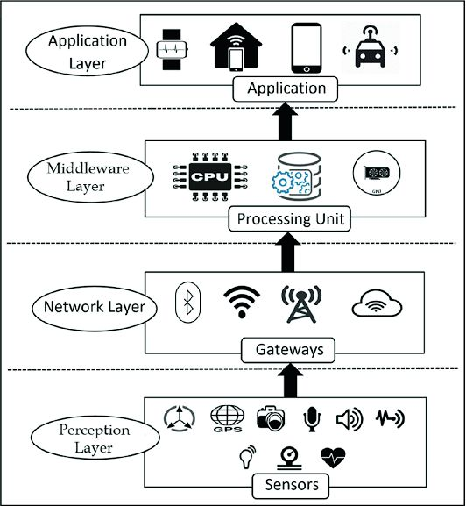

While it is true that no two IoT projects are the same, the main layers have always stayed consistent. Ever since the first research on IoT was done, **the three-layer architecture** has been the dominant model for IoT applications. **The three layers are**:

1. Perception (or Devices)
2. Network
3. Middleware
4. Application

* **Perception (or Devices)**
* This is where the data comes from. The data could be gathered from any number of sensors on the connected device. Actuators, which act on their environment, are also at this layer of the architecture.
* **Network**
* The network layer describes how large amounts of data are moving throughout the application. This layer connects the various devices and sends the data to the appropriate back-end services.
* **Middleware**
* Middleware layer, this one store, analyzes, and pre-processes the data coming from the Transport layer. In modern software applications, this is often located on the edge of the cloud for low latency communications.
* **Application**
* Application: The application layer is what the users see. it can be an application to control a device in a smart-home, or a dashboard showing the status of the devices which are part of a system.

**4.5 Middleware is**

- In every device, there is an operating system as well as different applications. Middleware is software which is in the middle of an operating system and the applications working on it. It permits communication and data management for distributed applications by operating as a hidden translation layer. The term is considered vague since it is used to link two separate applications together. “Middleware is sometimes called plumbing because it connects two sides of an application and passes data between them.”

- Middleware delivers messaging services thereby enabling different applications to communicate by utilizing messaging frameworks like Web services, Simple Object Access Protocol (SOAP), JavaScript Object Notation (JSON) and Representational State Transfer (REST). Other than the above, at a primary level, middleware deliver facilities necessary to link applications together such as transaction management, concurrency, threading etc.

- Additional advanced execution of middleware concepts are incorporated into modern integration infrastructures such as API management software and enterprise service bus (ESB) to provide accountability, greater governance and risk management.

* 1. **Li-Fi in IOT**

With a rapid increase in the number of connected devices, some challenges appear which will be responded by increasing capacity and by improving energy efficiency, cost and spectrum utilization as well as providing better scalability for handling the increasing number of the connected devices. For the vision of all-communicating world relative to today’s network, the overall technical aim is to provide a system idea that supports:

* 1000 times increased data volume per area
* 10 to 100 times increased number of connected devices
* 10 to 100 times increased typical user data rate
* 10 times extended battery life for low power Massive Machine Communication (MMC) devices
* times reduced End-to-End (E2E) latency

IoT would fit well and well in Li-Fi and be enabled by it. IoT needs multiple access points and this is easily done in Li-Fi since simple light bulbs are used and these can technically be any number of access points. Li-Fi would improve IoT to becoming a ubiquitous network because it could be installed anywhere users might like light and data services: bus shelters, train stations, street lights, tourist information kiosks could all provide data transmission as well as light. IoT can be enabled by Li-Fi in indoor communication for it has a small range of coverage compared to Wi-Fi. Undersea, things connected to above sea level, will continue connectivity because light reaches undersea.

**Chapter four**

**Underwater communication Using Li-Fi**

* 1. **Introduction of Underwater communication using Li-Fi**

This project to make underwater communication easier. The proposed system underwater communication system using Li Fi technology which provides protection against ship collisions on the sea. Li Fi (Light Fidelity) is an emerging technology which uses the visible light spectrum for communication.

Currently, communication underwater is next to impossible because radio waves are quickly absorbed in water. In contrast, light can easily travel in water and is able to penetrate for large distances. This can be used to enable communication between divers, diver to mini-sub, the diver to a drilling rig, or even military communication underwater.

**5.2 Powerful of Li-Fi in Underwater communication**

**We will work on underwater communication use case so,** we will discuss the powerful of Li-Fi in **Underwater communication**. In so many ways, Li-Fi is considered more superior to Wi-Fi. Data transmission tests have reached speeds of up to 224Gbps, roughly 100 times faster than Wi-Fi. While these were only lab tests, speeds at even a small percentage of that figure in the real world still indicate having a significant advantage over Wi-Fi. The visible light spectrum is also broader as opposed to RF – about 10,000 larger than the entire radio frequency spectrum. This is crucial especially with the data demands of today. It provides many available frequencies to which tasks can be offloaded, freeing up much-needed space for 5G, so; we using Li-Fi technology in underwater communication to help divers to communicate with each other and prevent the ships from collision.

**5.3 The problem with underwater communication**

**The problem** with underwater communication with our current technology, divers use hand signals, radio, or acoustic or digital light signals to communicate. Diving has become a common way of performing research in the underwater living world. One of the major problems with diving is the health issues faced by the divers during diving and there comes the need for monitoring diver’s health While these allow fairly effective communication, they have their limitations. In recent days, Underwater Communication is used to keep track of obstacles and ocean species. Wi-Fi cannot be used in underwater communication because in water the Radio Waves are get absorbed. Li-Fi can be used underwater because light can penetrate deep water. Li-Fi can used to communicate with others to send or receive audio and texts The audio and video transmission achieve a maximum distance of 200m. The Li-Fi transmitter and receiver are used to analyze the performance and various conditions such as quality, intensity, and distance. The key advantage of Li-Fi is low power consumption and very high data rates. So, Li-Fi make the communication underwater easier, it can used in long distance and We can use it in underwater communication rather than Wi-Fi technology because the Wi-Fi cannot use in underwater communication.

**5.4 The Stakeholders** **are**

**Target Customer:**

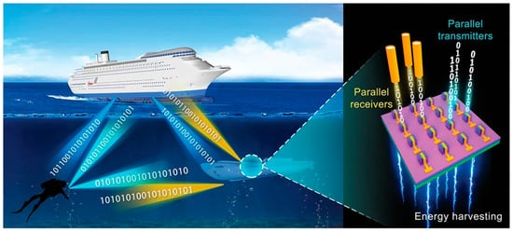

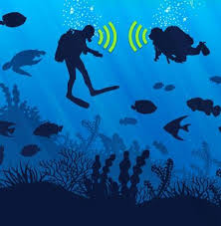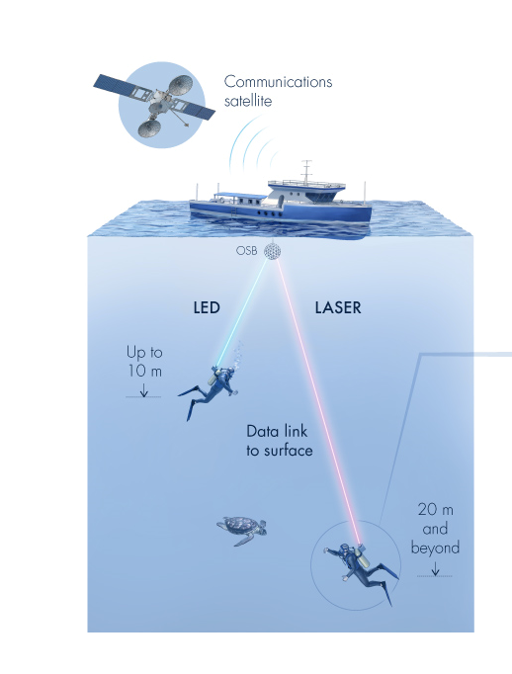

* **Rescue Operations in Sea:** If the rescue operation taking place in the sea, then the one information can be transfer from one ship to another.
* **For Defense Operations:** The proposed system is useful in the Defense operation. While patrolling if the Unknown Ship is found in the sea, then the patrolling ship also send the information to the Central authority.
* **Fisherman Security**: Our System is useful for the fisherman also if the fisherman finds some problem in sea or his ship then he can send the message to the other ship or central authority.
* **Coast Guard**: By using LI-FI system we can be allocating the area for the Fisherman these effects the fisherman never crosses the sea boundary so the war between the Countries minimized.
* **Alerts for Ships**: If the hurricane occurs in the sea, then the alert information can be sent to the ship also if the pyrites in the sea is available then the message also sent to the ships.
* **GPS System**: By using LI-FI system we can be allocating the area for the Fisherman these effects the fisherman never crosses the sea boundary so the war between the Countries minimized.
* **Ship Navigation:** By using the Li-Fi System We Can Navigate the ships so the current activity or location of the ship can be detected and it is helpful for the preventing the ship from major accidents.

**Chapter Five**

**Hardware Components**

**5.1 Transmitter Part**

**5.1.1 9v battery connector:** supply power to the circuit

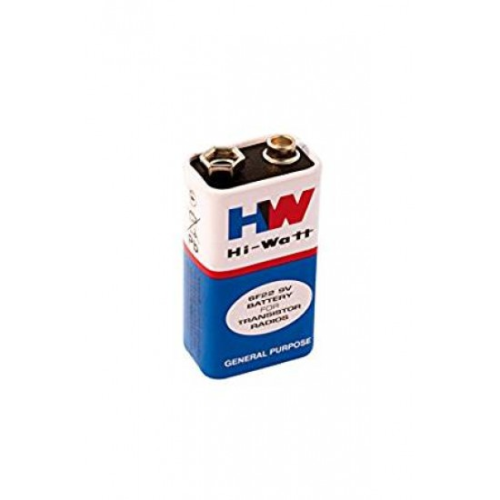

**5.1.2 220-ohm resistor**: reduce current flow, and, at the same time, act to lower voltage levels within circuits. It's also used to limit current flow, to adjust signal levels, bias active elements, and terminate transmission lines.

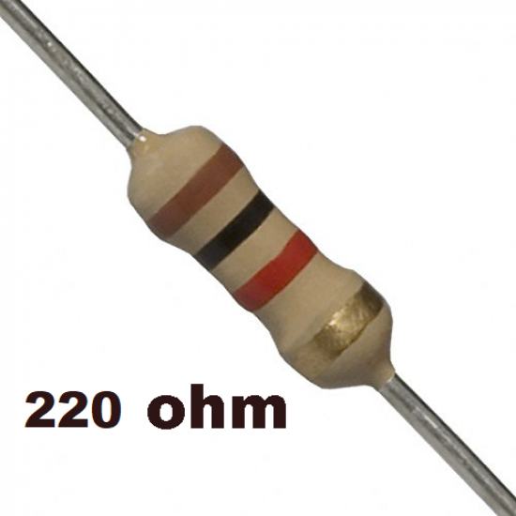

**5.1.3 LED:** LED lamps can be used for the transmission of data in visible light.

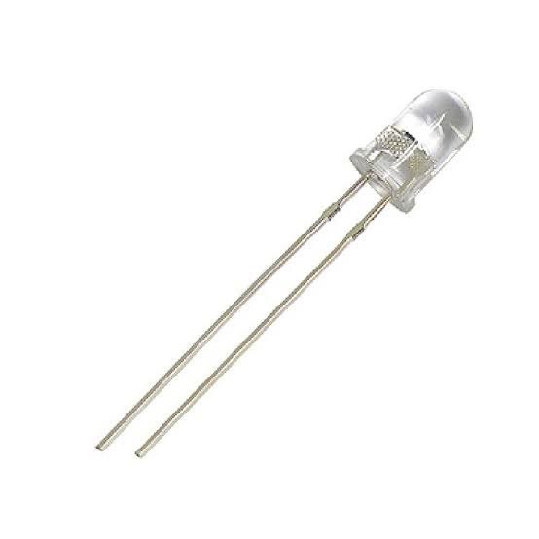

**5.2.3 Jack**: to connect the mobile (sound source in general) with the battery and led lights

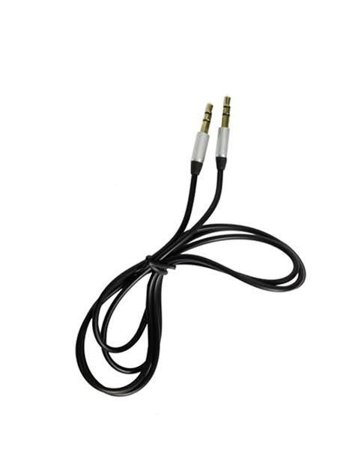

* 1. **Receiver part**
     1. **Solar panel:** Li-Fi solar panel will not only produce solar power but also act as a data receiver of Li-Fi signals.

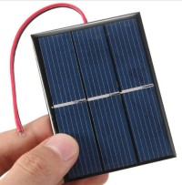

* + 1. **Speaker:** converts Electrical or Analog signals to the audible form to reach the Receptor. It converts the sound signal with the help of Electromagnets present in the Speaker. Hence the Receptor Receive the input has been transmitted from the transmitter

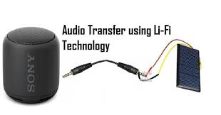

**5.2.3 Aux**: to connect the mobile (sound source in general) with the battery and led lights



**Chapter sex**

**Experiments**

**6.1 Transmission audio on air:**

The full form of Li-Fi is Light Fidelity. Li-Fi basically is a Wireless Communication Technology which uses Visible Light for Data transmission. Li-Fi is designed to use LED Light Bulbs similar to those present in our homes and offices. However, there is a slight difference in these Li-Fi LED Light Bulbs and Normal LED Light Bulbs. These Li-Fi LED Light Bulbs transmit Data through the Light given off by them and these Light Signals are received by Photoreceptors. Now a question in your mind will arise that what is a Photoreceptor. So, in terms of Technology, a Photoreceptor is a Sensor that detects Light by capturing Photons (Photons are Light Particles). In Labs, with stronger LED's and Powerful Technology Researchers have gained speeds up to 10 Gigabits per Second (10 0Gbps) through Li-Fi. So now explain how the experiments work.

## **Step 1: Gathering the Materials**

1. 9v battery connector
2. 220-ohm resistor
3. LED
4. Solar panel
5. Speaker
6. Aux connection
7. Mobile

This Experiment will not cost you more than 7 Bucks and the best part of this Experiment is that you don't need any Arduino or Programming. We need very simple materials for it. The List of the Materials is given below:

1. Aux connection
2. LED
3. 9 Volt Battery
4. 220 Ohm Resistor
5. Solar Panel
6. Mobile
7. Speaker

**Step 2: Preparing the Jacks**

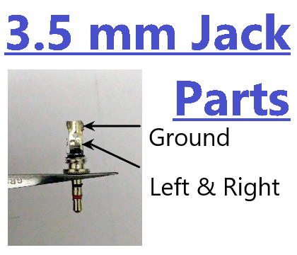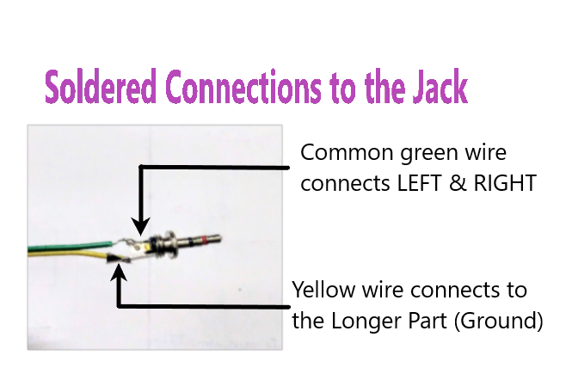

First we are going to get our Jacks ready. In Jack you will find 3 parts (Terminals) as shown above.

The Highest Part is known as GROUND.

The next 2 Shorter Parts are known as LEFT and RIGHT

1. Unscrew the Cap on the Top of the Jack
2. Solder a wire on the GROUND first.
3. Then Strip a wire longer from the front and solder it on the both shorter parts (LEFT and RIGHT) from one side only
4. Pass your both wires through the hole on the cap and screw it back on
5. Repeat the same steps for the other jack too and your both Jacks are ready to go

**Step 3: Building the LiFi Transmitter**

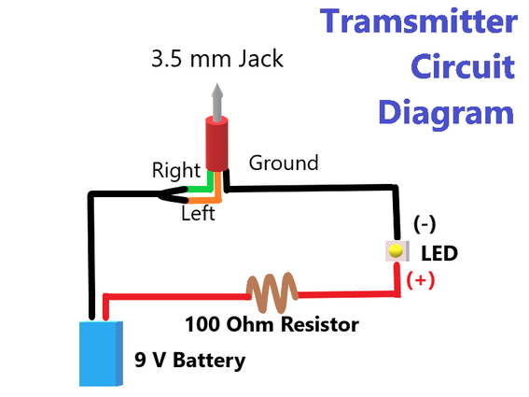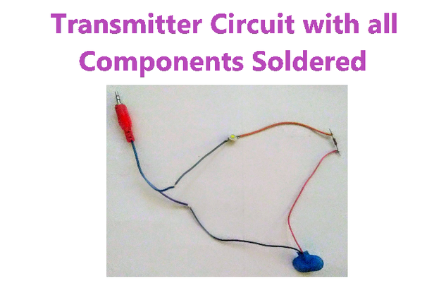

Now we are going to build the Transmitter which will emit the Li-Fi Signals

I've Given the Circuit Diagram for the Transmitter above, Steps for building the Transmitter are given below:

1. Connect the Negative (-ve) Terminal of your LED with the GROUND terminal of the Headphone Jack
2. Now, Connect the Resistor to the Positive (+ve) Terminal of the LED
3. Connect the Positive (+ve) Terminal of your 9 Volt Battery with the Resistor
4. Now at last connect the Negative (-ve) Terminal of the Battery with the common wire of LEFT and RIGHT Terminals from the 3.5 mm Jack to Complete the Circuit.

So, we’ve made the Li-Fi Transmitter and now its turn to make the receiver that will Receive these Li-Fi signals.

**Step 4: Building the LiFi Receiver**

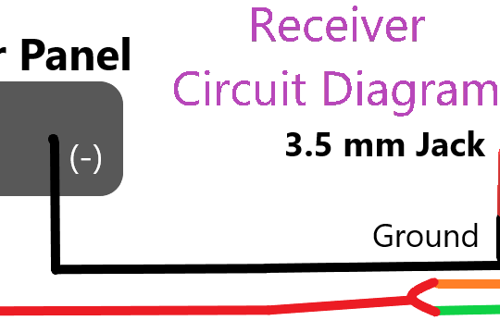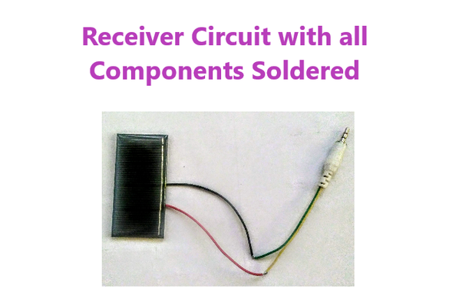

In the last step we made the Transmitter of Li-Fi signals and now its turn to make the Receiver to receive these Li-Fi signals.

The Circuit Diagram is given above for the Receiver, The steps for making the Receiver are given below:

1. Solder the wires to the Positive (+ve) and Negative (-ve) Terminals of the Solar Panel
2. Now, Connect the Negative (-ve) Terminal to the GROUND Terminal of the other Jack
3. The Positive (+ve) Terminal is left so connect the Positive (+ve) Terminal of the Solar Panel to the Common wire of LEFT and RIGHT Terminals from the jack to complete the Circuit.

Now our Receiver is also built and the only thing left is to assemble both the circuits in a cardboard box.

## **Step 5: Building the Cases for the Transmitter and Receiver**

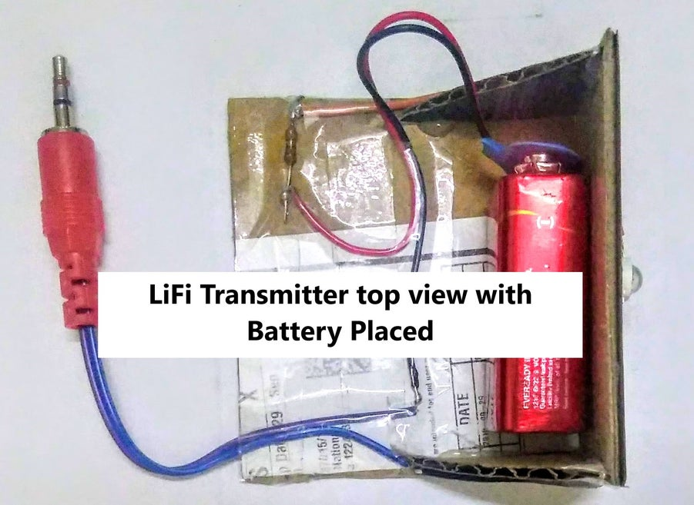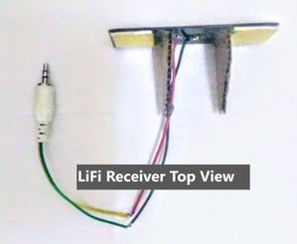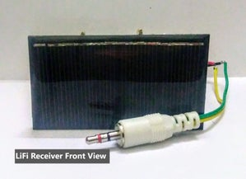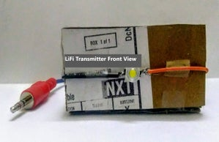

We have completed the Circuits of the Transmitter and Receiver and now its turn to make Protective Case for them. By this our Project will look neat and will be safer than open Circuits.

## **Step 6: Testing Time!**

1. Take the Li-Fi Transmitter Jack and Connect it with your Phone through Jack
2. Take the Li-Fi Receiver Jack and Connect it with a Pre-Amplified Speaker in the AUX Input Port
3. Place the Li-Fi Transmitter and Li-Fi Receiver Face to Face with each other with a Distance of about 5 cm (or 2 inches) between them.
4. Connect the Battery to the 9 Volt Battery Connector in the Li-Fi Transmitter
5. The LED will Light up
6. Play any song on the Connected Phone

You will observe that the song will also start to play on the speaker too!

This happens because The Li-Fi Transmitter will transmit the audio signals from your Phone through Light from the LED to The Li-Fi Receiver that is the Solar Panel. The Solar Panel will collect these Li-Fi Signals and send them to the Speaker. Then the Speaker will amplify these Li-Fi Signals and convert them to Audio Signals again.

**References:**

<https://lifi.co/>

<https://ieeexplore.ieee.org/document/9526524>